**BIKE CRASH DETECTION**

## A PROJECT REPORT

***Submitted by,***

**Mr. ABHI KIRAN N H - 20201CSE0853**

**Mr. SHIVA KUMAR G -20201CSE0870**

**Mr. HARSHITH N R - 20201CSE0849**

**Mr. ESHWAR RAJU A G – 20201CSE0875**

### *Under the guidance of,*

**Mr. AFROJ ALAM**

***in partial fulfillment for the award of the degree of***

**BACHELOR OF TECHNOLOGY**

**IN**

**COMPUTER SCIENCE AND ENGINEERING**

**At**



**PRESIDENCY UNIVERSITY**

**BENGALURU**

**JANUARY 2024**

**PRESIDENCY UNIVERSITY**

**SCHOOL OF COMPUTER SCIENCE ENGINEERIN**

**CERTIFICATE**

This is to certify that the Project report **BIKE CRASH DETECTION** being submitted by “ Abhi kiran N H, Shiva Kumar G, Harshith N R, Eshwar Raju A G” bearing roll number(s) “ 20201CSE0853, 20201CSE0870, 20201CSE0849, 20201CSE0875” in partial fulfilment of requirement for the award of degree of Bachelor of Technology in Computer Science and Engineering is a bonafide work carried out under my supervision.

|  |  |
| --- | --- |
| **Mr. AFROJ ALAM**  Assistant Professor  School of CSE&IS  Presidency University | **Dr. PALLAVI**  HoD  School of CSE&IS  Presidency University |

|  |  |  |
| --- | --- | --- |
| **Dr. C. KALAIARASAN**  Associate Dean  School of CSE&IS  Presidency University | **Dr. L. SHAKKEERA**  Associate Dean  School of CSE&IS  Presidency University | **Dr. SAMEERUDDIN KHAN** Dean  School of CSE&IS  Presidency University |

**PRESIDENCY UNIVERSITY**

**SCHOOL OF COMPUTER SCIENCE ENGINEERIN**

**DECLARATION**

We hereby declare that the work, which is being presented in the project report entitled **BIKE CRASH DETECTION** in partial fulfilment for the award of Degree of **Bachelor of Technology** in **Computer Science and Engineering**, is a record of our own investigations carried under the guidance of **Mr. AFROJ ALAM, ASSISTANT PROFESSOR,** **School of Computer Science Engineering, Presidency University, Bengaluru.**

We have not submitted the matter presented in this report anywhere for the award of any other Degree.

|  |
| --- |
| Abhi Kiran N H – 20201CSE0853 |
|  |
| Shiva Kumar G – 20201CSE0870 |
|  |
| Harshith N R – 20201CSE0849 |
| Eshwar Raju A G – 20201CSE0875 |

**ABSTRACT**

The Bike Crash Detection System represents an innovative approach to enhance the safety of bike riders by incorporating automated emergency alert features. Its primary goal is to utilize cutting-edge sensor technologies and communication modules for real-time detection of bike accidents, followed by prompt notifications to emergency contacts containing precise accident locations.

The system integrates various sensors, including accelerometers, to monitor the bike's movements and identify patterns indicative of collisions. Employing machine learning algorithms enables real-time analysis of sensor data, allowing accurate differentiation between normal riding conditions and potential accidents. Upon crash detection, the system initiates an automatic emergency alert mechanism, utilizing GPS technology to pinpoint the accident location. Subsequently, distress messages are sent to pre-defined emergency contacts, providing details such as the accident location, time, and a brief incident description. This automated notification system ensures rapid response times from emergency services or designated contacts, potentially saving crucial time in critical situations.

The project strives to enhance overall road safety by offering an additional layer of protection for bike riders. The proposed system is designed to be compact, cost-effective, and easily integrable with existing bike infrastructure. The implementation of this intelligent Bike Crash Detection System aims to reduce the severity and consequences of bike accidents, ultimately fostering a safer environment for bikers on the road. The primary motivation behind this work is to provide timely assistance to injured individuals at the accident spot.

In response to the increasing number of road accidents involving cyclists, this paper introduces an intelligent bike crash detection system. The system is tailored to enhance cyclist safety by swiftly identifying accidents and alerting predefined emergency contacts. It combines advanced sensor technologies, real-time data analysis, and seamless communication to offer a comprehensive solution for accident prevention.

Upon detecting a crash, the system automatically sends distress messages to a predefined list of emergency contacts. These messages include the cyclist's location, detected impact force, and a timestamp. The integration of GPS technology ensures accurate geolocation, facilitating a rapid response from emergency services or nearby contacts.

To encourage widespread adoption, the system is designed for easy integration into existing bike infrastructure, emphasizing energy efficiency to prolong battery life. The user interface is intuitive, allowing cyclists to customize emergency contact lists, notification preferences, and system settings through a dedicated mobile application.

Initial testing and simulations confirm the effectiveness of the proposed system in accurately detecting bike crashes and promptly notifying emergency contacts. By providing cyclists with an intelligent and proactive safety mechanism, this system contributes to accident prevention, reducing the severity of injuries and potentially saving lives on the road.

**ACKNOWLEDGEMENT**

First of all, we indebted to the **GOD ALMIGHTY** for giving me an opportunity to excel in our efforts to complete this project on time.

We express our sincere thanks to our respected dean **Dr. Md. Sameeruddin Khan**, Dean, School of Computer Science Engineerin, Presidency University for getting us permission to undergo the project.

We record our heartfelt gratitude to our beloved Associate Deans **Dr. Kalaiarasan C and Dr. Shakkeera L,** School of Computer Science Engineering, Presidency University and Dr. Pallavi, Head of the Department, School of Computer Science Engineerin, Presidency University for rendering timely help for the successful completion of this project.

We are greatly indebted to our guide **Mr Afroj Alam, Assistant Professor**, School of Computer Science Engineering, Presidency University for his inspirational guidance, and valuable suggestions and for providing us a chance to express our technical capabilities in every respect for the completion of the project work.

We would like to convey our gratitude and heartfelt thanks to the University Project-II Coordinators **Dr. Sanjeev P Kaulgud, Dr. Mrutyunjaya MS** and also the department Project Coordinators Mr. Afroj Alam.

We thank our family and friends for the strong support and inspiration they have provided us in bringing out this project.

**Abhi kiran N H**

**Shiva Kumar G**

**Harshith N R**

**Eshwar Raju A G**

**LIST OF TABLES**

|  |  |  |  |
| --- | --- | --- | --- |
| **Sl. No.** | **Table Name** | **Table Caption** | **Page No.** |
| 1 | Table 1.1 | Gantt Chart | 26 |

**LIST OF FIGURES**

|  |  |  |  |
| --- | --- | --- | --- |
| **Sl. No.** | **Figure Name** | **Caption** | **Page No.** |
| 1 | | Fig 1.1 | Arduino Nano | 18 |
| 2 | | Fig 1.2 | LM 2596 | 19 |
| 3 | | Fig 1.3 | Power Supply | 20 |
| 4 | | Fig 1.4 | GSM Module | 21 |
| 5 | | Fig 1.5 | Accelerometer | 22 |
| 6 | | Fig 1.6 | NEO 6M GPS | 23 |
| 7 | | Fig 2.1 | Message Display | 31 |
| 8 | | Fig 2.2 | Model | 32 |
| 9 | | Fig 3.1 | GPS Data Reading | 33 |
| 10 | | Fig 3.2 | GSM Message Reading | 33 |
| 11 | | Fig 4.1 | Model | 43 |
| 12 | | Fig 4.2 | Serial Monitor 1 | 44 |
| 13 | | Fig 4.3 | Serial Monitor 2 | 44 |
| 14 | | Fig 4.4 | Code 1 | 45 |
| 15 | | Fig 4.5 | Code 2 | 45 |
| 16 | | Fig 4.6 | Code 3 | 46 |
| 17 | Fig 4.7 | Code 4 | 46 |

**TABLE OF CONTENTS**

|  |  |  |
| --- | --- | --- |
| **CHAPTER NO.** | **TITLE** | **PAGE NO.** |

**ABSTRACT iv**

**ACKNOWLEDGEMENT vi**

**1 INDRODUCTION 1**

**1.1 Introduction to Domain 1**

**1.2 Introduction to Prooject 2**

**1.3 Scope of Project 3**

**2 LITERATURE SURVEY 5**

**2.1 Research and Technical Paper 5**

**2.1.1 MDPI 5**

**2.1.2 IJERT 6**

**3 RESEARCH GAPS OF EXISTING**

**METHODS 8**

**3.1 Existing Methods 8**

**3.2 Pros and Cons 10**

**3.2.1 Pros 10**

**3.2 .2 Cons 11**

**4 PROPOSED METHADOLOGY 13**

**4.1 Methadology 13**

**5 OBJECTIVES 15**

**5.1 Objectives 15**

|  |  |  |
| --- | --- | --- |
| **CHAPTER NO.** | **TITLE** | **PAGE NO.** |

**6 SYSTEM DESIGN AND**

**IMPLEMENTATION 18**

**6.1 Components 18**

**6.1.1 Arduino nano 18**

**6.1.2 LM 2596 19**

**6.1.3 Power Supply Module 20**

**6.1.4 GSM Module 21**

**6.1.5 Accelerometer 22**

**6.1.6 NEO 6M GPS 23**

**6.2 Functional Requirements 23**

**6.3 Non Functional Requirements 24**

**6.4 Software Requirements 25**

**7 TIME LINE OF PROJECT 26**

**8 OUTCOMES 27**

**9 RESULTS AND DISCUSSIONS 31**

**9.1 Results 31**

**10 CONCLUSION 33**

**10.1 Location data Reading From GPS 33**

**REFERENCES 35**

**APPENDIX – A 36**

**PSEUDO CODE 36**

**APPENDIX – B 43**

**Screen Shot 43**

**CHAPTER-1**

**INTRODUCTION**

**1.1 Introduction to Domain**

With the rising popularity of biking for both transportation and recreation, there is an increasing demand for innovative solutions to address safety concerns related to bike accidents. These incidents can result in severe injuries or even fatalities, underscoring the need for enhanced safety measures for cyclists. Our project focuses on the development of a Bike Crash Detection System, designed to promptly alert authorities in case of an accident and provide crucial details about the incident location.

This proposed system seeks to overcome the limitations of traditional safety tools like helmets and reflective gear by leveraging advancements in sensor technologies, machine learning, and communication systems. By integrating intelligent sensors onto bicycles, our goal is to establish a proactive safety system capable of real-time accident detection and response. The significance of this initiative lies in its potential to minimize the impact of bike accidents by reducing emergency response times. The system not only identifies crash events but also transmits essential information, such as the accident location, to designated contacts, ensuring a swift and targeted response.

In the context of the growing trend towards smart and connected technologies, the integration of a Bike Crash Detection System aligns with the broader objective of fostering safer and more efficient transportation systems. This project aims to contribute to ongoing endeavors to enhance road safety for cyclists, creating a more secure environment for those who opt for biking as a mode of commuting or leisure. Through the application of cutting-edge technologies, our aspiration is to make biking a safer and more accessible transportation option in modern urban settings.

**1.2 Introduction to project:**

In the dynamic realm of urban commuting, the growing adoption of bicycles as a sustainable and effective means of transportation emphasizes the necessity for inventive safety solutions. Unfortunately, bike accidents persist as a significant concern, prompting the development of advanced systems to ensure the well-being of riders. Our project centers on the establishment of a Bike Crash Detection System, incorporating elements like Arduino Nano, ADXL-345 accelerometer, GSM SIM800L module, GPS NEO-6M module, and LM2596 step converter. This system not only identifies bike accidents but also autonomously dispatches precise accident location messages to specified contacts.

The fundamental components of our project synergize to create a sophisticated safety apparatus. The Arduino Nano acts as the system's central processing unit, managing data acquisition and processing. The ADXL-345 accelerometer serves as the primary motion sensor, capturing abrupt changes indicative of a crash. The GPS NEO-6M module provides accurate location information, enabling the system to pinpoint the exact coordinates of the accident. For seamless communication, the GSM SIM800L module facilitates the transmission of emergency messages, while the LM2596 step converter ensures a stable power supply for dependable operation.

Our project resides at the crossroads of advanced hardware and safety innovation. The Bike Crash Detection System not only identifies accidents but also utilizes GPS technology to relay real-time accident location information to predefined contacts. This autonomous and swift response mechanism has the potential to transform bike safety, adding an extra layer of protection for riders.

As we delve into the technical intricacies of our project, our aim is to contribute to the ongoing initiatives in enhancing biking safety, particularly in urban settings. By amalgamating cutting-edge components and intelligent algorithms, our system aligns with the broader vision of integrating smart technologies into everyday transportation, ultimately fostering a secure and trustworthy biking experience for riders.

**1.3 Scope of this project:**

The Bike Crash Detection Project, with its automated accident location messaging feature, encompasses a broad scope that spans technical, societal, and safety considerations. Here are key areas of focus for this project:

1. Elevated Biker Safety:

The primary goal is to significantly enhance the safety of cyclists by introducing an additional protective layer through real-time accident detection and swift communication of the accident location.

2. Decreased Emergency Response Time:

The project strives to minimize the duration for emergency services or designated contacts to reach the accident scene. Swift communication of the accident location is crucial for providing timely medical assistance and support.

3. Integration of Advanced Sensor Technologies:

The project involves incorporating and optimizing advanced sensor technologies, including accelerometers and GPS modules. The scope extends to refining these sensors to accurately detect crash events while minimizing false positives.

4. Arduino and Sensor Integration:

The utilization of Arduino Nano and sensors like ADXL-345, GPS NEO-6M, and others offers a scope for developing robust hardware and software interfaces. This includes programming the Arduino to efficiently process data from sensors, analyze it, and trigger appropriate responses.

5. Implementation of Communication Modules:

Integrating GSM modules like SIM800L for communication adds a layer of complexity. The scope includes configuring and optimizing the communication module to ensure the reliable transmission of accident location messages.

6. Power Management:

Incorporating a step converter such as LM2596 involves efficiently managing power requirements. Balancing power consumption and performance is a critical aspect of the project.

7. User-Friendly Design:

The project's scope extends to crafting a user-friendly system that is easy for cyclists to install, use, and maintain. Consideration should be given to overall design, user interfaces, and any additional features that enhance usability.

8. Scalability and Adaptability:

The system should be designed with scalability in mind, allowing for future enhancements or integration with other smart transportation systems. It should also be adaptable to different bike models and environments.

9. Regulatory Compliance:

Ensuring compliance with relevant regulations and standards for safety devices is within the scope. This includes adherence to communication protocols, privacy concerns, and any legal requirements.

10. Public Awareness and Education:

The success of the project relies on raising awareness and gaining acceptance among cyclists. Therefore, there is a scope for public awareness campaigns and educational initiatives to inform cyclists about the system's benefits and encourage its adoption.

By addressing these areas, the Bike Crash Detection Project aims to have a meaningful impact on biker safety and contribute to the advancement of intelligent transportation systems.

**CHAPTER-2**

**LITERATURE SURVEY**

**2.1 RESEARCH AND TECHNICAL PAPERS:**

# 2.1.1 A Framework and IoT-Based Accident Detection System to Securely Report an Accident and the Driver’s Private Information ( @MDPI ):

The provided literature review delves into various aspects of vehicle tracking systems and accident detection mechanisms, shedding light on the diverse technologies and approaches employed in these solutions. Here is a condensed summary of the primary findings and contributions from each cited source:

1. GPS and GSM-Based Vehicle Tracking System:

The author proposes a straightforward vehicle tracking system utilizing GPS and GSM technology, intended for applications such as theft detection and monitoring school buses. Future work is envisioned to include monitoring additional vehicle parameters, such as an LPG gas sensor and gas leak alarm.

2. IoT-Based Framework for Vehicle Overspeed Detection:

Presents an IoT-enabled overspeed detection system that estimates the time for a vehicle to travel from origin to destination.

Utilizes radar technology for assessing vehicle speed, wirelessly transmitting data to authorities.

Incorporates a GPS-sensing module and a connection app for predicting accuracy (40-80%) based on internet speed and connectivity.

3. Accident Detection System with SMS Notifications:

Authors propose a fully functional accident detection system employing a shock sensor and SMS notifications via a GSM module. The system exhibits robustness by continuously sending crash notifications until confirmed by authorities.

4. Accelerometer and GPS-Based Accident Identification:

Identifies accidents using an accelerometer and GPS in conjunction with a smartphone.

Enhances system dependability by storing accident data on a server, acknowledging the potential for failure in case of server issues.

5. Smartphone-Based Accident Reporting:

Khot et al. present a smartphone-based system using an accelerometer to recognize accidents and report accident locations to emergency personnel. The system's reliance on a single point of failure increases the likelihood of erroneous accident alerts.

6.Single-Sensor Accident Detection System:

Chaturvedi et al. propose an accident detection and reporting system utilizing a single sensor. The system transmits the accident location to the police station when an incident occurs, emphasizing simplicity but potentially compromising accuracy.

7. Automatic Accident Detection using VANET and IoT:

Introduces a prototype for automatic accident detection using Vehicular Adhoc Network (VANET) and IoT.

Mechanical and medical sensors in the car detect accidents and assess the severity of emergency situations.

In summary, the literature covers a spectrum of vehicle tracking and accident detection systems, exploring technologies such as GPS, GSM, IoT, accelerometers, and VANET. The findings underscore the strengths and potential limitations of these systems, emphasizing the significance of accuracy, reliability, and the mitigation of single points of failure to ensure the effectiveness of safety and monitoring solutions.

**2.1.2 Smart Accident Detection and Alert System ( IJERT ):**

The proposed system for detecting vehicle crashes introduces an innovative approach by utilizing an ensemble deep learning model based on multi-modal data, with the aim of improving the accuracy and efficiency of accident detection. Key functionalities include prompt user notifications and, if required, automated communication of the precise accident location to the nearest hospital and a designated person specified by the user.

The system architecture comprises a sophisticated set of components. The accident detection

process is initiated by the Shock sensor SW-420, in conjunction with an accelerometer sensor. Simultaneously, the Impact sensor, triggered by the release of the airbag during an accident, works alongside the shock sensor to identify vibrations caused by the collision. Data from these sensors, including information from the Accelerometer ADXL 345 for determining the accident direction, is transmitted to the Raspberry Pi. The microcontroller is programmed to execute necessary actions based on the collected data. Following an accident, the victim receives a prompt for confirming the incident. If there is no response within a specified timeframe, the system utilizes geographical data from the GPS module NEO 6M to send accident details to the hospital and specified relatives through pre-installed WiFi, employing a Voice Messaging API for voice message transmission.

The system relies on the Extreme Gradient Boosting (XGBoost) algorithm, recognized for its efficiency and accuracy in addressing data science problems, particularly within the Gradient Boosting framework. XGBoost facilitates parallel tree boosting (GBDT, GBM), contributing to swift and accurate analysis of multi-modal data for effective accident detection.

**CHAPTER-3**

**RESEARCH GAPS OF EXISTING METHODS**

**3.1 Existing methods:**

Identifying research gaps in a bike crash detection project involving Arduino Nano, ADXL-345 accelerometer, GSM SIM800L, GPS NEO-6M, and LM2596 step converter is crucial in various dimensions:

1. Integration and Optimization:

There is a necessity for thorough research to optimize the integration of selected components. This entails investigating how the Arduino Nano efficiently manages data from the ADXL-345 accelerometer and NEO-6M GPS module, ensuring real-time processing and minimal latency in crash detection.

2. Algorithmic Enhancements:

Further research is warranted to refine the crash detection algorithm. While the ADXL-345 accelerometer provides acceleration data, enhancing the algorithm to differentiate between regular biking activities and actual accidents is pivotal. Exploring machine learning approaches for pattern recognition presents a valuable avenue.

3. Energy Efficiency and Power Management:

Research gaps exist in methods to improve energy efficiency and power management. Optimizing the performance of the LM2596 step converter to extend the system's battery life, especially in scenarios with limited power resources, is an area requiring investigation.

4. Real-world Testing and Validation:

Thorough real-world testing and validation are essential for the practical deployment of the system. Research gaps persist in understanding the system's performance under diverse biking conditions, terrains, and environmental factors, necessitating robust testing to assess reliability in various scenarios.

5. User Interface and Human Factors:

Research should concentrate on designing the user interface and addressing human factors. Understanding how riders interact with the system, receive alerts, and provide feedback is crucial. Gaps exist in determining the most user-friendly and intuitive interface, ensuring quick response and minimal distraction for the rider.

6. Privacy and Ethical Considerations:Research is needed on privacy implications and ethical considerations. Given the system's involvement in location tracking and communication, understanding user concerns, implementing robust privacy measures, and adhering to ethical standards are vital research gaps.

7. Multi-sensor Integration:

Exploring the integration of additional sensors for comprehensive accident detection is an important research area. Combining data from multiple sensors, such as gyroscopes or additional accelerometers, has the potential to improve crash detection accuracy and reduce false positives.

8. Adaptability to Different Bike Models:

Research gaps exist in ensuring the system's adaptability to various bike models. Understanding how variations in bike structures and components may impact crash detection and location tracking performance is crucial for widespread applicability.

9. Network Connectivity and Redundancy:

Investigating the system's behavior in scenarios with fluctuating network connectivity is a research gap. Additionally, exploring redundancy mechanisms to ensure successful transmission of emergency messages, even in challenging network conditions, is crucial for system reliability.

Addressing these research gaps will contribute to developing a more robust, efficient, and user-friendly bike crash detection system, enhancing its potential for real-world deployment and improving overall road safety for bikers.

**3.2 Pros and Cons:**

**3.2.1 Pros:**

Initially, the incorporation of the ADXL-345 accelerometer serves as a pivotal element in the system, enabling immediate recognition of sudden changes in acceleration – a crucial indicator of potential crashes. This real-time monitoring capability establishes the foundation for swift and accurate accident detection.

Once a crash is identified, the system leverages the GPS NEO-6M module to pinpoint the exact location of the incident. The combination of GPS coordinates and the GSM SIM800L module facilitates the instant transmission of distress messages to predefined emergency contacts. This not only accelerates emergency services' response but also ensures an efficient and precise reaction by providing the precise accident coordinates.

The integration of the LM2596 step converter plays a critical role in sustaining a consistent power supply for the system. This not only guarantees uninterrupted operation but also enhances the project's dependability, especially in situations with limited or inconsistent power resources.

Additionally, the utilization of the Arduino Nano as the microcontroller provides a cost-effective and accessible solution. This affordability enhances the project's potential for broad adoption, catering to a diverse range of bikers.

The project's versatility extends beyond accident detection, allowing for real-time monitoring of the bike's location, providing riders with immediate safety feedback. This user-friendly interface enhances the overall user experience, promoting acceptance and regular usage.

Moreover, the modular nature of the components and the utilization of widely available technologies make the system scalable and adaptable to various bike models and user preferences. This scalability ensures the seamless integration of safety features into different biking scenarios.

In summary, the bike crash detection project offers a comprehensive and efficient solution to enhance rider safety. By incorporating advanced sensor technologies and communication modules, it not only promptly identifies accidents but also facilitates a quick and accurate emergency response, ultimately contributing to a safer biking experience.

**3.2.2 Cons:**

A notable limitation lies in the potential occurrence of false positives and false negatives during crash detection. The ADXL-345 accelerometer, despite its capability to sense sudden changes in acceleration, may incorrectly interpret certain non-crash events as accidents or may fail to detect subtle but significant crashes. Achieving an optimal balance between sensitivity and specificity presents a challenge, necessitating meticulous calibration of the crash detection algorithm.

Furthermore, the reliance on GSM technology for emergency messaging introduces vulnerabilities related to network coverage and connectivity issues. In remote or low-coverage areas, the system might encounter difficulties in promptly transmitting distress messages, thereby compromising the effectiveness of the emergency response mechanism. Additionally, potential delays in GSM network responsiveness could impact the system's reliability during crucial moments.

The accuracy of GPS positioning raises another concern. While the NEO-6M GPS module provides reasonably accurate location data, challenges may arise in urban canyons or areas with poor satellite visibility, compromising the precision of location information. This limitation becomes particularly critical in scenarios where exact accident coordinates are vital for emergency services to swiftly locate the injured biker.

The LM2596 step converter, while contributing to stable power management, introduces a potential point of failure. Malfunctions or failures in the step converter could disrupt the power supply to critical components, affecting the overall reliability of the crash detection system. Ensuring the robustness of power management components becomes crucial for sustained system operation.

Moreover, the cost associated with implementing and maintaining such a system may serve as a barrier to widespread adoption, particularly in regions with budget constraints or among bikers with limited resources. Affordability emerges as a critical factor influencing the accessibility and acceptance of the technology among diverse user groups.

Lastly, privacy concerns may arise due to the continuous monitoring and transmission of location data. User hesitancy in adopting the technology may result from perceived privacy risks. Addressing these concerns and implementing transparent data handling practices are imperative for building user trust and fostering acceptance.

In conclusion, while the bike crash detection project presents valuable safety features, it encounters challenges related to accuracy in crash detection, network connectivity, component reliability, affordability, and privacy considerations. Mitigating these drawbacks is essential to unlock the full potential of the system and ensure its effective deployment in real-world biking scenarios.

**CHAPTER-4**

**PROPOSED MOTHODOLOGY**

**4.1 Methodology:**

1. Overview of System Architecture:

Key Components:

Arduino Nano: Serves as the microcontroller for data processing and decision-making.

ADXL-345 Accelerometer: Detects abrupt accelerations indicative of a potential crash.

GSM SIM800L: Facilitates communication for sending emergency messages.

GPS NEO-6M: Determines the precise location of the bike.

LM2596 Step Converter: Ensures a stable power supply for system components.

2. Logic for Crash Detection:

Continuous monitoring of the bike's acceleration by the ADXL-345 accelerometer.

Initiates crash detection logic upon detecting a sudden, abnormal acceleration.

3. Processing of Data:

Arduino Nano processes data from the accelerometer to validate a potential crash.

Analyzes patterns in acceleration data to differentiate normal riding conditions from crash events.

4. Retrieval of GPS Location:

Upon confirming a crash, activates the GPS NEO-6M module to retrieve real-time bike location coordinates.

5. Composition of Emergency Message:

Arduino Nano compiles an emergency message, detailing the accident, including GPS coordinates.

6. Power Management:

The LM2596 Step Converter ensures a consistent power supply, optimizing system reliability.

7. Activation of GSM Module:

Activates the GSM SIM800L module to establish communication with predefined emergency contacts.

8. Transmission of Message:

Utilizes the GSM module to send an emergency message, conveying accident details, such as location coordinates and timestamp.

9. Prioritization of Emergency Contacts:

Prioritizes sending messages to emergency contacts in a predefined list, potentially including reaching out to medical assistance or law enforcement.

10. Redundancy and Confirmation:

Implements redundancy checks to ensure reliable message delivery.

Continues sending messages to emergency contacts until confirmation is received, ensuring a prompt response.

11. User Confirmation Prompt:

Simultaneously prompts the bike rider for accident confirmation.

If confirmed, the system proceeds with emergency messaging; if denied, terminates the emergency alert process.

12. Continuous Monitoring:

The system remains in a vigilant monitoring state, ready to detect and respond to potential accidents.

13. User Feedback Mechanism:

Incorporates a feedback mechanism allowing users to review the emergency response and provide feedback on system performance.

14. Testing and Calibration:

Conducts rigorous testing to validate crash detection accuracy, message transmission reliability, and overall system performance.

Calibrates sensor thresholds and timings based on real-world scenarios to optimize system responsiveness.

This proposed methodology delineates the stages involved in developing a bike crash detection system with emergency messaging capabilities, incorporating Arduino Nano, ADXL-345 accelerometer, GSM SIM800L, GPS NEO-6M, and LM2596 Step Converter components. Ongoing testing and refinement are imperative to ensure the system's reliability and efficacy in practical scenarios.

**CHAPTER-5**

**OBJECTIVES**

**5.1 Objectives:**

1. Accident Detection:

Develop a robust algorithm utilizing the ADXL-345 accelerometer to accurately discern between regular biking activities and potential accidents.

2. Multi-Modal Sensor Integration:

Integrate the ADXL-345 accelerometer, GPS NEO-6M, and LM2596 Step Converter with Arduino Nano to establish a comprehensive multi-modal sensing system for accident detection.

3. GPS Location Accuracy:

Ensure precision in location tracking using the GPS NEO-6M module to furnish accurate accident location information.

4. Power Management:

Implement effective power management through the LM2596 Step Converter to guarantee steady and dependable power supply for all system components.

5. Real-Time Data Processing:

Optimize the Arduino Nano for real-time processing of sensor data to minimize detection and response times in the event of a crash.

6. Emergency Messaging System:

Integrate the GSM SIM800L module for timely communication, enabling the system to dispatch emergency messages to predefined contacts upon detecting a crash.

7. Message Content and Format:

Develop a standardized message format incorporating crucial accident details, such as location coordinates and timestamp, for coherent communication with emergency contacts.

8. Emergency Contact Prioritization:

Implement a prioritization system to dispatch emergency messages to predefined contacts, ensuring prompt dissemination of information to the most critical contacts.

9. User Confirmation Prompt:

Design a user interface prompting the bike rider for confirmation of the detected accident, allowing immediate feedback to the system.

10. Redundancy and Reliability:

Incorporate redundancy checks into the system to confirm the successful transmission of emergency messages, ensuring reliability in alerting emergency contacts.

11. User-Friendly Interface:

Create an intuitive and user-friendly interface, providing clear feedback and response options for users to interact seamlessly with the system.

12. Response Time Optimization:

Minimize the time between accident detection and the transmission of emergency messages to enhance the system's responsiveness in critical situations.

13. Feedback Mechanism:

Implement a feedback mechanism enabling users to assess the emergency response and offer insights into the system's performance.

14. Testing and Validation:

Conduct thorough testing under diverse biking scenarios to validate the system's accuracy in crash detection, location tracking, and message transmission.

15. Scalability and Adaptability:

Design the system with scalability in mind, allowing for future enhancements and adaptation to different bike models and environmental conditions.

16. Documentation and Guidelines:

Provide comprehensive documentation and guidelines for users on system installation, operation, and troubleshooting.

By fulfilling these objectives, the bike crash detection project aspires to develop a reliable and efficient system that enhances the safety of bike riders through prompt accident detection and communication of critical information.

**CHAPTER-6**

**SYSTEM DESIGN & IMPLEMENTATION**

**6.1.Components:**

**6.1.1 Arduino Nano:**

The Arduino Nano stands out as a compact, adaptable, and cost-effective microcontroller board developed within the Arduino family. Tailored for projects demanding a small footprint and extensive functionality, the Nano incorporates key features that contribute to its versatility and widespread utility:

1. Microcontroller: Fueled by the ATmega328P microcontroller, the same chip found in the Arduino Uno, ensuring a reliable and familiar processing unit.

2. Size and Form Factor: Characterized by its diminutive form, the Nano is particularly suited for projects constrained by limited space considerations.

3. Pin Configuration: With a pinout resembling larger Arduino counterparts like the Uno, the Nano provides a user-friendly interface for those accustomed to various Arduino models.

4. Voltage Regulator:Boasting an onboard voltage regulator, the Nano accommodates a broad spectrum of input voltages (typically 7-12V) and delivers a stable 5V output.

5. USB Interface: Featuring a built-in USB interface, the Nano facilitates easy connection to a computer for both programming and power supply.

6. Clock Speed: The ATmega328P on the Nano typically operates at 16MHz, ensuring ample processing power for diverse applications.

7. Memory: The Nano is equipped with 32KB of flash memory for program storage, 2KB of SRAM for variable storage, and 1KB of EEPROM for non-volatile data retention.

8.I/O Ports: With a variety of digital and analog input/output pins, the Nano supports versatile connections to sensors, actuators, and other components.

9. Programming: Programming the Arduino Nano is accomplished through the Arduino IDE via a USB connection. Users can code in the Arduino language, a simplified variant of C/C++.

10. Compatibility: The Nano seamlessly integrates with various Arduino shields and modules, augmenting its adaptability for diverse applications.

11. Applications: Widely employed in projects spanning robotics, embedded systems, wearable devices, and other electronic ventures where space constraints are paramount.

12. Community Support: As an integral part of the Arduino ecosystem, the Nano benefits from an extensive and engaged community. Users can access comprehensive documentation, tutorials, and forums for robust support and collaborative efforts.

Whether catering to hobbyists, students, or professionals, the Arduino Nano emerges as a condensed and capable platform, catering to a broad spectrum of electronic projects. Its adaptability and user-friendly attributes render it a favored choice within the thriving maker. 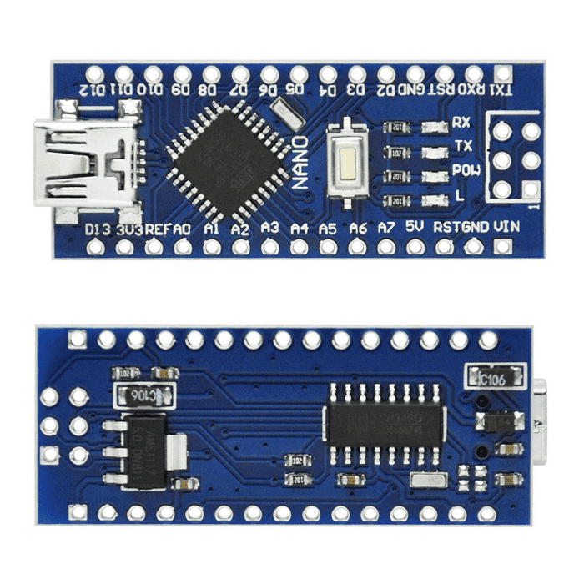

1.1 arduino nano

# 6.1.2. LM2596 Step Down Power Module:

# The LM2596 Step Down Power Module serves as a vital component in electronic circuits, functioning as a voltage regulator to efficiently convert higher input voltages into a stable and lower output voltage. Its primary utility lies in projects demanding a consistent power supply for delicate components or devices. Employing a buck converter topology, the LM2596 reduces the input voltage while concurrently increasing the output current, ensuring a dependable and constant power provision. Renowned for its compact size and straightforward operation, the LM2596 finds widespread applications, ranging from powering microcontrollers and sensors in electronic ventures to playing a pivotal role in battery charging circuits. Its adjustable output voltage capability adds to its versatility, allowing adaptation to the specific voltage needs of diverse electronic elements. In summary, the LM2596 Step Down Power Module is highly regarded for its efficiency, compact design, and adaptability, establishing it as an indispensable asset for electronic enthusiasts, engineers, and hobbyists.Lm2596S

# 1.2 LM 256

# 6.1.3. Power Supply Module:

# A crucial element in electronic systems, a power supply module performs the vital task of furnishing a stable and regulated electrical voltage to energize diverse components within a circuit. These modules, available in various types such as linear and switching power supplies, are crafted to convert input power from sources like wall outlets or batteries into a consistent output voltage suitable for the connected electronic devices. Beyond voltage regulation, power supply modules often incorporate safety features like overcurrent protection, short circuit protection, and thermal protection, ensuring the well-being and durability of the linked components. In the realm of electronics, power supply modules play a central role by facilitating the dependable functioning of microcontrollers, sensors, and other integrated circuits. Their adaptability to different input sources and voltage requirements underscores their indispensability across a broad spectrum of applications, spanning consumer electronics to industrial automation systems.Buy AC-DC Power Supply Module 12V 6A Switching Power Supply Board

# 1.3 Power supply

# 6.1.4. GSM Module:

# The SIM800L GSM module, designed by SIMCOM, stands out as a compact and adaptable communication module that enables GSM (Global System for Mobile Communications) connectivity in electronic projects and devices. Widely utilized for mobile communication and SMS-centric applications, this module operates across diverse GSM frequencies, ensuring compatibility on a global scale. Its compact form factor makes it well-suited for integration into projects with limited space. Notably, the SIM800L supports GPRS (General Packet Radio Service) for data transmission, extending its capabilities beyond voice calls and SMS to include internet connectivity. Controllable and configurable through an AT command set, the module interfaces seamlessly with microcontrollers or other host devices. Its energy efficiency, demonstrated through low power consumption and standby modes, renders it particularly apt for battery-operated applications. Frequently employed in IoT (Internet of Things) projects, remote monitoring systems, and various contexts requiring mobile communication, the SIM800L GSM module emerges as a reliable and cost-effective solution for wireless connectivity.Buy GPRS SIM800L GSM Module With Antenna Online at Lowest Price

# 1.4 GSM

# 6.1.5. Accelerometer:

# The ADXL335 accelerometer stands out as a highly adaptable sensor crafted to measure acceleration along three axes – X, Y, and Z, offering crucial data for an extensive array of applications. Manufactured by Analog Devices, this analog accelerometer relies on MEMS (Micro-Electro-Mechanical Systems) technology, featuring minute microstructures responsive to acceleration changes, translating them into electrical signals. Characterized by three sensitive axes, each housing a suspended mass element responsive to acceleration forces, the ADXL335 produces analog voltage outputs proportional to the applied acceleration. Its broad dynamic range and low power consumption make it well-suited for various applications, encompassing tilt sensing, motion detection, and vibration analysis. Renowned for its compact size and user-friendly design, the ADXL335 is a preferred choice among hobbyists, engineers, and researchers seeking to seamlessly integrate precise motion-sensing capabilities into diverse electronic projects, spanning robotics, drones, wearable devices, and inertial measurement units.Buy 3 Axis Analog ADXL335 Accelerometer Online At Best Price In India

# 1.5 accelerometer

# 6.1.6. NEO-6M GPS Module

# The NEO-6M GPS module stands out as a compact and effective Global Positioning System (GPS) receiver designed to deliver precise and real-time positioning information. Crafted by u-blox, the NEO-6M harnesses advanced navigation technology, allowing it to receive signals from multiple Earth-orbiting satellites and determine accurate geographical coordinates, altitude, and velocity. This module relies on the MediaTek chipset, boasting heightened sensitivity and a swift time-to-first-fix (TTFF) for rapid and dependable acquisition of satellite signals. Utilizing a serial communication protocol, typically employing NMEA (National Marine Electronics Association) sentences, the NEO-6M communicates seamlessly with a host microcontroller or device. With its small physical footprint, low energy consumption, and compatibility across various applications, such as navigation systems, tracking devices, and unmanned aerial vehicles (UAVs), the NEO-6M GPS module has emerged as a favored choice for projects demanding precise and timely location data. Its adaptability and straightforward integration render it a valuable asset in the creation of location-centric applications spanning diverse industries.

# Ublox NEO-6M GPS Module : Amazon.in: Electronics

# 1.5 GPS

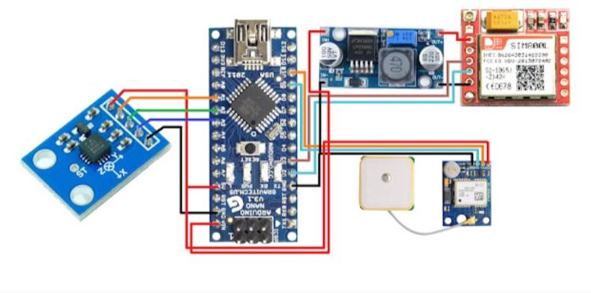

# Circuit diagram

# 6.2 Funtional Requirements:

# The primary objective of the bike crash detection project is to integrate essential functional requirements, ensuring a reliable system for promptly detecting bike accidents and transmitting messages regarding the accident location. To begin with, the system needs a robust algorithm that utilizes data from the ADXL-345 accelerometer to accurately identify bike crashes based on specific acceleration patterns indicative of an impact. This algorithm will be integrated into the Arduino Nano, serving as the central processing unit responsible for real-time data processing. The inclusion of the GPS NEO-6M module will facilitate the immediate retrieval of precise location coordinates following a crash event. Enabling the creation of an emergency messaging system, the GSM SIM800L module will allow the system to dispatch SMS messages containing crucial accident details, including location coordinates, to predefined emergency contacts. The LM2596 Step Converter will play a vital role in power management, ensuring a stable and continuous power supply for all components. The user interface will feature a prompt for the bike rider to confirm the detected accident, with a prioritization mechanism in place to ensure swift notifications to critical emergency contacts. The system will incorporate redundancy checks to verify the successful transmission of emergency messages, optimizing response time in critical situations. Furthermore, the project will encompass a user-friendly interface, continuous monitoring capabilities, thorough testing under various biking scenarios, and scalability for future enhancements and adaptability to diverse bike models and environments. A comprehensive feedback mechanism will be integrated, allowing users to assess the emergency response and provide valuable insights into the system's performance.

# 6.3. Non Funtional Requirements:

# The success of bike crash detection projects hinges on several critical non-functional requirements that impact overall system performance, usability, and reliability. Firstly, with respect to performance, the system should exhibit minimal latency in identifying and responding to bike accidents, ensuring swift and precise location information. It should possess scalability to accommodate potential increases in user numbers or system complexity. Reliability is of utmost importance, necessitating a high level of system availability and robustness to withstand diverse environmental conditions and usage scenarios. The system must showcase adaptability by being compatible with different bike models and environments. In terms of usability, the user interface should be user-friendly and intuitive, catering to both technical and non-technical users. Adherence to security and privacy standards is crucial, safeguarding sensitive user information and ensuring the confidentiality and integrity of transmitted data. Energy efficiency is another non-functional requirement, requiring optimized power consumption to extend the system's battery life and minimize environmental impact. Additionally, the system should be designed with maintainability considerations, allowing for easy updates, troubleshooting, and future enhancements. Lastly, compliance with regulatory standards and certifications, particularly those related to wireless communication and electronic devices, is imperative for legal adherence and fostering user trust in the developed bike crash detection system.

# 6.4. Software Requirements:

The development of a bike crash detection project involves creating a sophisticated software system that effectively integrates the Arduino Nano, ADXL-345 accelerometer, GSM SIM800L, GPS NEO-6M, and LM2596 Step Converter. At the core of the software is an algorithm responsible for processing data from the ADXL-345 accelerometer to accurately identify patterns indicative of a bike crash. The firmware for Arduino Nano needs to be programmed to execute this algorithm in real-time, ensuring prompt and precise crash detection. The software should facilitate seamless communication between the accelerometer and the GPS module, allowing the system to retrieve exact location coordinates immediately after a crash. Integration with the GSM module is crucial for

composing and sending emergency messages containing accident details to predefined contacts. The software should efficiently manage power distribution through the LM2596 Step Converter, optimizing energy consumption for prolonged system operation. Additionally, a user-friendly interface should be designed to prompt the bike rider for confirmation of the detected accident, providing user input options. The system's response time should be optimized to minimize the duration between crash detection and emergency message transmission. Implementing redundancy checks and error handling mechanisms is essential to ensure the reliability of message delivery. Overall, the software must facilitate the smooth interaction of these components, ensuring the robust functionality of the bike crash detection system while prioritizing efficiency, reliability, and user-friendliness.

**CHAPTER-7**

**TIMELINE FOR EXECUTION OF PROJECT**

**(GANTT CHART)**

|  |  |  |  |
| --- | --- | --- | --- |
| **SL. No** | **Review** | **Date** | **Execution of Project** |
| **1** | **Review 0** | **12/10/2023** | **Research and implementation of idea** |
| **2** | **Review 1** | **10/11/2023** | **25% execution is done** |
| **3** | **Review 2** | **31/11/2023** | **50% execution is done** |
| **4** | **Review 3** | **28/12/2023** | **100% execution is done** |
| **5** | **Viva Voice** | **11/01/2024** | **Implementation of project** |

**Table 1.1 Gantt chart**

**CHAPTER-8**

**OUTCOMES**

**8.1 Outcomes**

The bike crash detection project is designed to yield multifaceted outcomes, with the primary objective of significantly enhancing the safety of bike riders through the prompt and accurate detection of accidents. A pivotal outcome involves the implementation of a robust crash detection algorithm utilizing the ADXL-345 accelerometer, seamlessly integrated with the Arduino Nano, ensuring the precise identification of bike accidents based on acceleration patterns. This outcome is instrumental in advancing rider safety.

Upon detecting an accident, the system's capability to swiftly retrieve accurate location coordinates from the GPS NEO-6M module stands out as a critical achievement. The integration with the GSM SIM800L module facilitates the generation and transmission of emergency messages containing vital accident details, such as location coordinates, to predefined contacts. This outcome guarantees that immediate notifications are sent to emergency contacts, thereby increasing the likelihood of timely assistance.

Another significant outcome is the utilization of the LM2596 Step Converter for efficient power management, contributing to a stable and continuous power supply for all system components. This outcome enhances the overall reliability and longevity of the system.

From a user perspective, the project outcomes include the development of a user-friendly interface that prompts bike riders for confirmation of detected accidents, providing a mechanism for user input and feedback. The prioritization of emergency contacts and the incorporation of redundancy checks further bolster the reliability of the system, ensuring that critical contacts receive notifications promptly and that emergency messages are transmitted successfully.

In summary, the outcomes of the bike crash detection project are aligned with the overarching goal of leveraging technology to improve road safety for bikers. The project's success is measured by its ability to accurately detect accidents, relay precise accident information, and facilitate timely assistance through automated messaging to emergency contacts. Ultimately, the project strives to make a meaningful impact on road safety by providing an automated and efficient system for responding to bike accidents.

**CHAPTER-9**

**RESULTS AND DISCUSSIONS**

**9.1 Results**

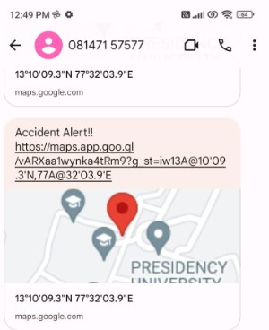

**2.1 message display**

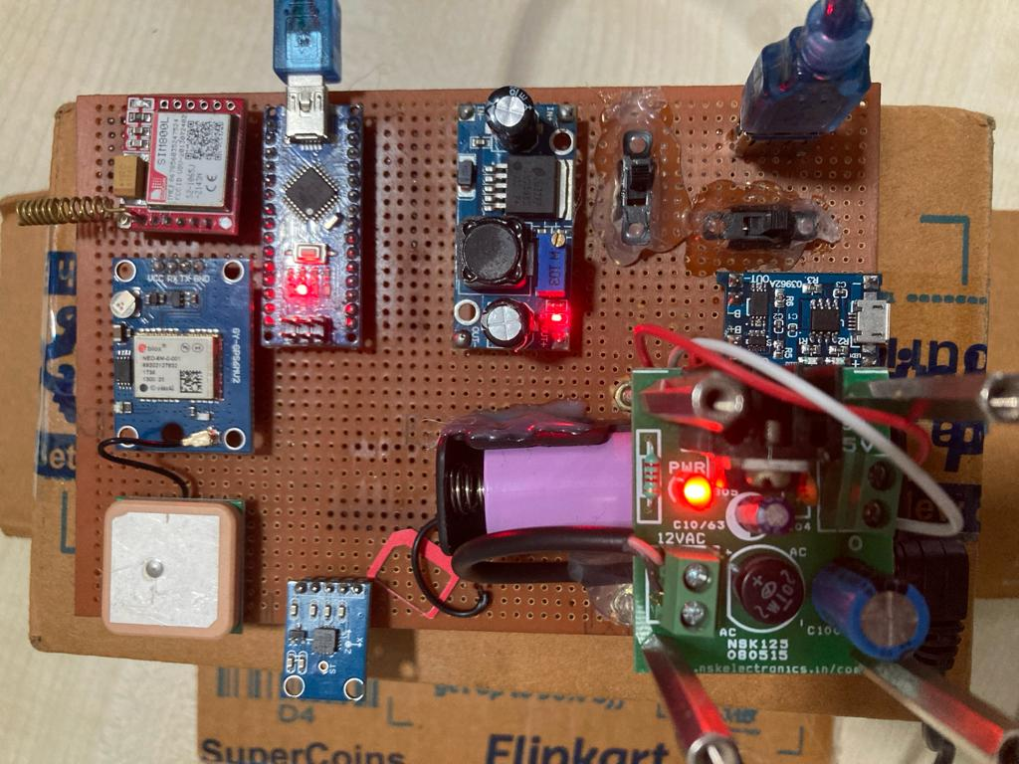

**2.2 model**

**CHAPTER-10**

**CONCLUSION**

**10.1 Location data Reading from GPS module**



3.1 GPS data reading

**10.2 Sending Alert message by GSM SIM 800L module**



3.2 GSM Message Reading

The provided code excerpt seems to be a segment of a program designed for initiating a call and sending an SMS using a SIM800 GSM module. Let's analyze the functionalities:

1. makeCall():

This function is responsible for initiating a call to a predefined emergency phone number (`EMERGENCY_PHONE`). It displays "calling..." on the Serial Monitor and sends the AT command (`ATD` followed by the phone number) to make the call. After a 20-second delay (20000 milliseconds), it sends the command to hang up the call (`ATH`). A subsequent delay of 1 second is included.

2. sendSms(String text):

This function is designed to send an SMS. It configures the SMS mode to text (`AT+CMGF=1`), waits for a second, and then sends the AT command to set the recipient phone number (`AT+CMGS`). Subsequently, it sends the actual message text along with the Ctrl+Z character (0x1A) to signify the end of the message. A 1-second delay follows the message transmission.

The function then outputs "Waiting for SMS response..." and reads and displays any available data from the SIM800 module. Finally, it prints "SMS Sent Successfully."

Please take note of the use of `EMERGENCY_PHONE`, assumed to be a constant representing the emergency phone number. Ensure that this constant is correctly defined before implementing these functions. Additionally, it is advisable to incorporate error handling and response checks for increased robustness in real-world scenarios, particularly in resource-constrained environments like embedded systems. Handling responses from the SIM800 module to confirm the success or failure of operations is also recommended.

**REFERENCES**

1. M Kamruzzaman, Bangladesh: Alarming rise in road crashes, 2020, [online] Available: https://www.aa.com.tr/eniasia-pacific/bangladesh-alarming-rise-in-road-crashes/1692643.

2. M. M. Islam, Mohammad Mehedi Hassan and Eui-Nam Huh, "Sensor Proxy Mobile IPv6 (SPMIPv6) - A framework of mobility supported IP-WSN", 2010 13th International Conference on Computer and Information Technology (ICCIT), 2010.

3. M. M. Islam, Tien Dung Nguyen, Aymen Abdullah Al Saffar, Sang-Ho Na and Eui-Nam Huh, "Energy Efficient Framework for Mobility Supported Smart IP-WSN", Proc. 2nd International Conference on Computational Collective Intelligence Technologies and Applications, 2010

4. J. Santa, P. J. Fernández and M. A. Zamora, "Cooperative ITS for two-wheel vehicles to improve safety on roads", 2016 IEEE Vehicular Networking Conference (VNC), pp. 1-4, 2016.

5. Archana, G. Boomija, J. Manisha and V.K.G. Kalaiselvi, "Mission on! Innovations in bike systems to provide a safe ride based on IOT", 2017 2nd International Conference on Computing and Communications Technologies (ICCCT), pp. 314-317, 2017.

6. D. K. P. Gudavalli, B. S. Rani and C. V. Sagar, "Helmet operated smart E-bike", 2017 IEEE International Conference on Intelligent Techniques in Control Optimization and Signal Processing (INCOS), pp. 1-5, 2017.

7. D. N., A. P. and R. E. R., "Analysis of Smart helmets and Designing an IoT based smart helmet: A cost effective solution for Riders", 2019 1st International Conference on Innovations in Information and Communication Technology (ICIICT), pp. 1-4, 2019.

8.A. Fanca POP, A. Puscasiu, S. Folea and H. Vălean, "Trauma accident detecting and reporting system", 2018 IEEE International Conference on Automation Quality and Testing Robotics (AQTR), pp. 1-5, 2018.

9.Lee Youngmin, Yeh Hongjin, Kim Ki-Hyung and Choi Okkyung, "A real-time fall detection system based on the acceleration sensor of smartphone", International Journal of Engineering Business Management, 2018.

**APPENDIX-A**

**PSUEDOCODE**

#include <AltSoftSerial.h>

#include <TinyGPS++.h>

#include <Wire.h>

#include <SoftwareSerial.h>

const String EMERGENCY_PHONE = "+919110243131";

#define rxPin 2

#define txPin 3

SoftwareSerial sim800(rxPin, txPin);

AltSoftSerial neogps;

TinyGPSPlus gps;

#define xPin A1

#define yPin A2

#define zPin A3

int xaxis = 0, yaxis = 0, zaxis = 0;

int vibration = 2;

int devibrate = 75;

int sensitivity = 20;

boolean impact_detected = false;

unsigned long impact_time;

unsigned long alert_delay = 30000;

String latitude, longitude;

// Function prototypes

void makeCall();

void sendAlert();

void sendSms(String text);

void impact();

void setup() {

Serial.begin(9600);

sim800.begin(9600);

neogps.begin(9600);

// Initialize GSM module

sim800.println("AT");

delay(1000);

sim800.println("ATE1"); // Enable echo

delay(1000);

sim800.println("AT+CPIN?");

delay(1000);

sim800.println("AT+CMGF=1"); // Set SMS mode to text

delay(1000);

sim800.println("AT+CNMI=1,1,0,0,0");

delay(1000);

// Initialize accelerometer

xaxis = analogRead(xPin);

yaxis = analogRead(yPin);

zaxis = analogRead(zPin);

}

void loop() {

if (micros() - impact_time > 1999) impact();

if (impact_detected) {

impact_detected = false;

Serial.println("Impact detected!!");

Serial.print("Magnitude:");

Serial.println(sqrt(sq(xaxis) + sq(yaxis) + sq(zaxis)));

getGps();

makeCall();

delay(1000);

sendAlert();

}

while (sim800.available()) {

parseData(sim800.readString());

}

while (Serial.available()) {

sim800.println(Serial.readString());

}

}

void impact() {

impact_time = micros();

int oldx = xaxis;

int oldy = yaxis;

int oldz = zaxis;

xaxis = analogRead(xPin);

yaxis = analogRead(yPin);

zaxis = analogRead(zPin);

vibration--;

Serial.print("Vibration = ");

Serial.println(vibration);

if (vibration < 0) vibration = 0;

if (vibration > 0) return;

int deltx = xaxis - oldx;

int delty = yaxis - oldy;

int deltz = zaxis - oldz;

int magnitude = sqrt(sq(deltx) + sq(delty) + sq(deltz));

if (magnitude >= sensitivity) {

impact_detected = true;

vibration = devibrate;

} else {

magnitude = 0;

}

}

void parseData(String buff) {

Serial.println(buff);

unsigned int len, index;

index = buff.indexOf("\r");

buff.remove(0, index + 2);

buff.trim();

if (buff != "OK") {

index = buff.indexOf(":");

String cmd = buff.substring(0, index);

cmd.trim();

buff.remove(0, index + 2);

if (cmd == "+CMTI") {

index = buff.indexOf(",");

String temp = buff.substring(index + 1, buff.length());

temp = "AT+CMGR=" + temp + "\r";

sim800.println(temp);

} else if (cmd == "+CMGR") {

if (buff.indexOf(EMERGENCY_PHONE) > 1) {

buff.toLowerCase();

if (buff.indexOf("get gps") > 1) {

getGps();

String sms_data = "Accident Alert!!\r";

sms_data += "http://maps.google.com/maps?q=loc:";

sms_data += latitude + "," + longitude;

sendSms(sms_data);

}

}

}

}

}

void getGps() {

// Can take up to 60 seconds

boolean newData = false;

for (unsigned long start = millis(); millis() - start < 2000;) {

while (neogps.available()) {

if (gps.encode(neogps.read())) {

newData = true;

break;

}

}

}

if (newData) {

latitude = String(gps.location.lat(), 6);

longitude = String(gps.location.lng(), 6);

newData = false;

} else {

Serial.println("GPS data is not available");

latitude = "";

longitude = "";

}

Serial.print("Latitude= ");

Serial.println(latitude);

Serial.print("Longitude= ");

Serial.println(longitude);

}

void sendAlert() {

String sms_data = "Accident Alert!!\r";

sms_data += "";

sms_data += latitude + "," + longitude;

sendSms(sms_data);

}

void makeCall() {

Serial.println("calling....");

Serial.println("Sending SMS....");

sim800.println("ATD" + EMERGENCY_PHONE + ";");

delay(20000); // 20 sec delay

sim800.println("ATH");

delay(1000); // 1 sec delay

}

void sendSms(String text) {

sim800.println("AT+CMGF=1");

delay(1000);

sim800.print("AT+CMGS=\"" + EMERGENCY_PHONE + "\"\r");

delay(1000);

sim800.print(text);

delay(100);

sim800.write(0x1A);

delay(1000);

Serial.println("Waiting for SMS response...");

while (sim800.available()) {

Serial.write(sim800.read());

}

Serial.println("SMS Sent Successfully.");

}

**APPENDIX-B**

**SCREENSHOTS**



4.1 model

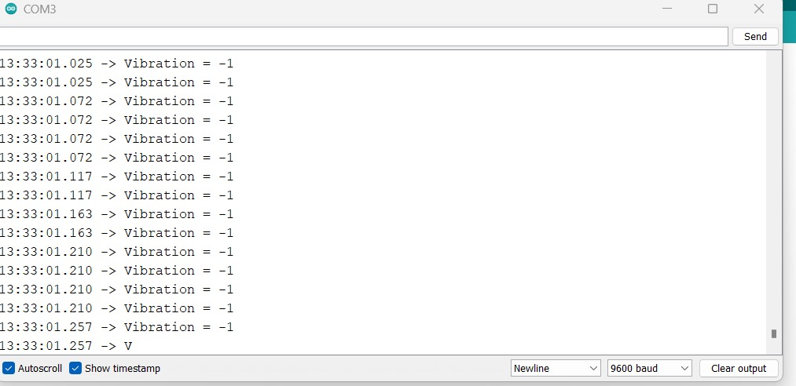

4.2 Serial monitor 1

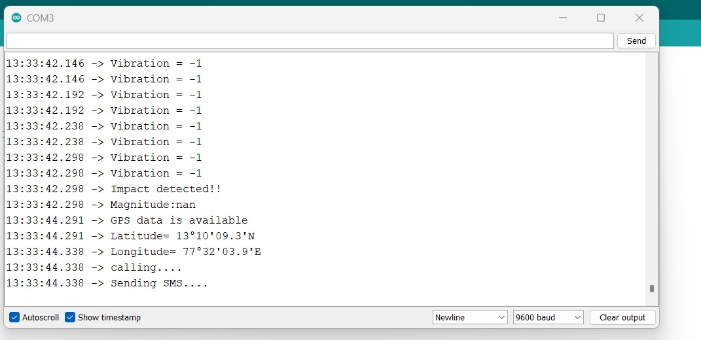

4.3 Serial Monitor 2

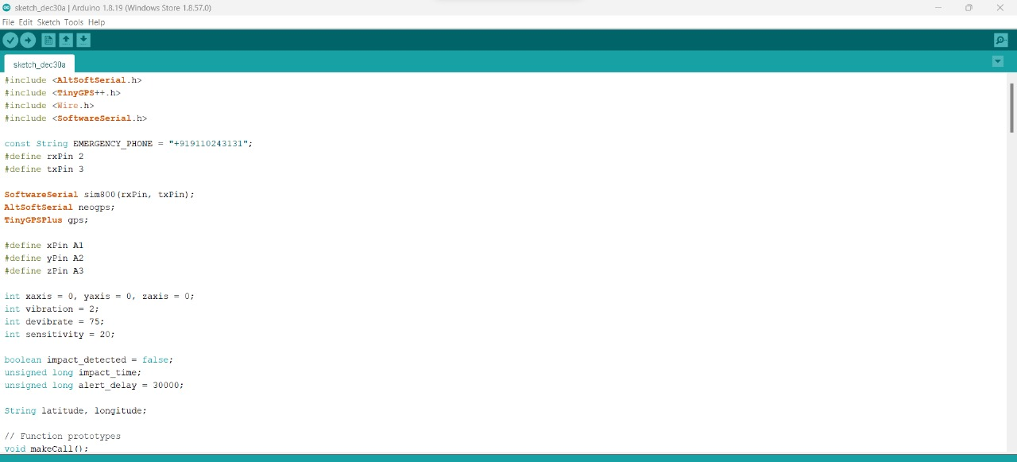

4.4 Code 1

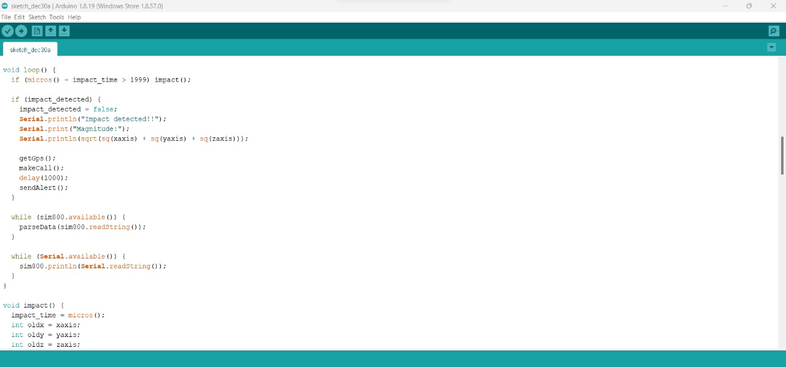

4.5 Code 2



4.6 Code 3



4.7 Code 4

**APPENDIX-C**

**ENCLOSURES**

**1. Conference Paper Presented Certificates of all students.**

**2. Include certificate(s) of any Achievement/Award won in any project related event.**

**3. Similarity Index / Plagiarism Check report clearly showing the Percentage (%). No need of page-wise explanation.**

**SUSTAINABLE DEVELOPMENT GOALS**

**The Bike Crash Detection project aligns with the Sustainable Development Goal of Decent Work and Economic Growth by fostering innovation in road safety technology. The implementation of this intelligent system not only enhances the safety of bike riders but also contributes to economic growth by promoting the development of cutting-edge solutions in the field of smart transportation. As the project envisions widespread adoption, it has the potential to generate employment opportunities and stimulate economic activities associated with the production, installation, and maintenance of the Bike Crash Detection System. By addressing critical safety concerns for bikers, the project simultaneously supports economic growth and facilitates the creation of decent work opportunities within the emerging landscape of intelligent transportation systems.**